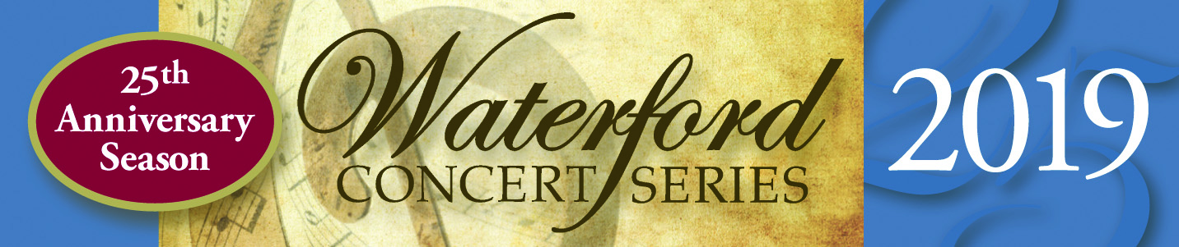

Brooklyn Rider, a string quartet called “the future of chamber music” (Strings), will perform an extraordinary program “Healing Modes” as the first concert of the 2019 Waterford Concert Series on Sunday, March 17 at 4 PM in the Waterford Old School, 40222 Fairfax St., Waterford, VA. (Sponsor of this concert is the Betty McGowin Charitable Trust.)

“Healing Modes” combines new works by five women composers with Ludvig Van Beethoven’s late quartet, Op. 132, noted for its sublime third movement Beethoven called Heiliger Dankesang…, or Song of Thanksgiving from a Convalescent to the Deity in the Lydian Mode.

The five new works were commissioned for Brooklyn Rider. All were written within the past year and touch on healing themes: refuge from war and troubles, bodily and mental health, lost culture recovered, borderlands, and the healing power of music. Caroline Shaw, composer of the first piece, won a Pulitzer for music at age 30 in 2013.

Beethoven’s Op. 132 triumphs over deafness, illness, temporary loss of creativity and spirit. It is a magnificent work that plumbs new depths of meaning with each hearing.

Brooklyn Rider is the perfect quartet to bring this program to thrilling life in Waterford. They are “four classical musicians performing with the energy of young rock stars..:” (Pittsburgh Post-Gazette). Johnny Gandesman and Colin Jacobsen, violins; Nicholas Cords, viola; and Michael Nicolas, cello—are Brooklyn Rider.
Tickets are $35 adult, $15 student. Subscriptions are now on sale for all five 2019 concerts for $135, a $40 savings over individual ticket prices. Subscribers also receive priority seating and an invitation to a reception with the artists following a concert. For info, directions and ticket purchase, please go to www.waterfordconcertseries.org. Book early: seating is limited!

The next concert will be Sunday, April 7, 4 PM: Camerata RCO, a chamber ensemble from the Royal Concertgebouw Orchestra of Amsterdam.
2019 marks the 25th anniversary of the Waterford Concert Series bringing musicians from all around the USA and the world to rural Loudoun County and the historic village of Waterford. For more information about celebrating 25 years of great classical music, please visit the website: www.waterfordconcertseries.org.

Media Contact: Lynne Adams, 571-246-7265

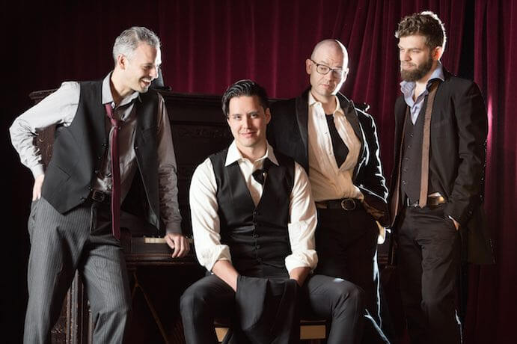
Brooklyn Rider Photo Credit: Erin Baiano

